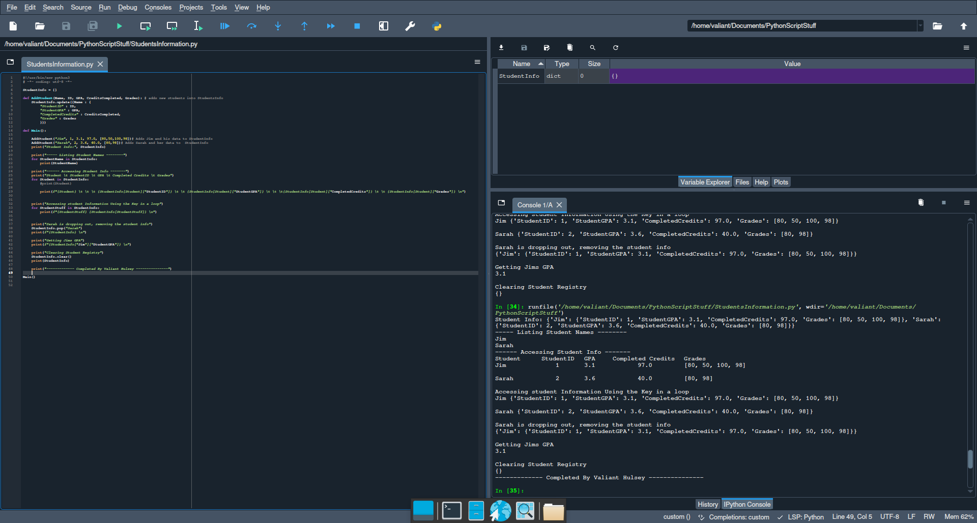

StudentInfo = {}

def AddStudent(Name, ID, GPA, CreditsCompleted, Grades): # adds new students into StudentsInfo

StudentInfo.update({Name : {

"StudentID" : ID,

"StudentGPA" : GPA,

"CompletedCredits" : CreditsCompleted,

"Grades" : Grades

}})

def Main():

AddStudent("Jim", 1, 3.1, 97.0, [80,50,100,98])# Adds Jim and his data to StudentInfo

AddStudent("Sarah", 2, 3.6, 40.0, [80,98])# Adds Sarah and her data to StudentInfo

print("Student Info:", StudentInfo)

print("----- Listing Student Names --------")

for StudentName in StudentInfo:

print(StudentName)

print("------ Accessing Student Info -------")

print("Student \t StudentID \t GPA \t Completed Credits \t Grades")

for Student in StudentInfo:

#print(Student)

print(f"{Student} \t \t \t {StudentInfo[Student]["StudentID"]} \t \t {StudentInfo[Student]["StudentGPA"]} \t \t \t{StudentInfo[Student]["CompletedCredits"]} \t \t {StudentInfo[Student]["Grades"]} \n")

print("Accessing student Information Using the Key in a loop")

for StudentStuff in StudentInfo:

print(f"{StudentStuff} {StudentInfo[StudentStuff]} \n")

print("Sarah is dropping out, removing the student info")

StudentInfo.pop("Sarah")

print(f"{StudentInfo} \n")

print("Getting Jims GPA")

print(f"{StudentInfo["Jim"]["StudentGPA"]} \n")

print("Clearing Student Registry")

StudentInfo.clear()

print(StudentInfo)

print("------------- Completed By Valiant Hulsey ---------------")

Main()